Question A
[114 marks]

- Imagine you are running a company creating a computer game that runs on mobile phones. The game is a massive multi-player game, meaning millions of people can interact with each other in the game world at the same time. What are the advantages of moving your game servers onto the cloud?

[8 marks]

- Why are virtual machines very useful in the cloud?

[6 marks]

- Please describe the negative consequences of over-provisioning hardware and how cloud providers can help to prevent over-provisioning.
[6 marks]

- Please describe why the MapReduce framework of Hadoop is so good for processing Big Data.

[10 marks]

- Suppose the implementers of Hadoop forgot to add the reducers into the MapReduce framework. So user programs cannot use reducers but they can still use mappers. Would this make the framework completely useless and why? If no, then please given an example what you can do using mappers only.

[6 marks]

- In the Hadoop MapReduce framework please explain what happens to the data as it is emitted from the mapper and arrives at the reducer. Also how does this help us to achieve the output that we desire?

[8 marks]

- Please explain why it is often more desirable to program in Pig and Hive compared to MapReduce.

[6 marks]

- Please describe the advantages of using Hive rather than SQL on a traditional relational database.

[6 marks]

- Please explain at a high level how Zookeeper works. Address the following two important aspects of Zookeeper.
  - How does Zookeeper use its distributed in-memory file system to perform coordination?
  - How does Zookeeper handle consistency across the Zookeeper nodes?

[8 marks]

- How does YARN allow multiple frameworks such as MapReduce and Spark to simultaneously use the same cluster?

[8 marks]

- Why is MapReduce bad for processing large data streams? What makes Storm better at handling data streams compared to MapReduce?

[8 marks]

- Why is MapReduce so inefficient at executing iterative graph algorithms such as Page Rank? Why is Pregel more efficient at processing iterative graph algorithms.

[8 marks]

- How does Spark handle complex iterative algorithms such as machine learning and graph analytics efficiently?

[6 marks]

- How does RDDs achieve fault tolerance?

[6 marks]

- Why is it that the majority of NoSQL stores do not support full ACID transactions?

[6 marks]

- Please explain the concepts shown in the diagram below.

[8 marks]
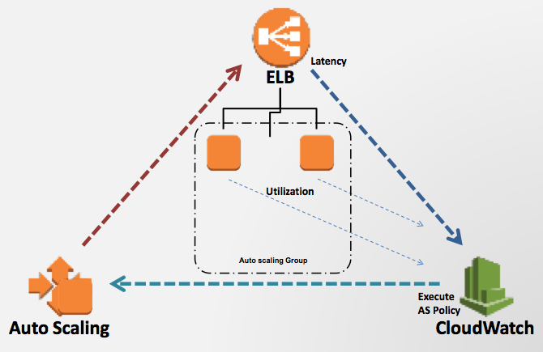

Question B
[30 marks]
Given the data set we used in lab 8 shown below.

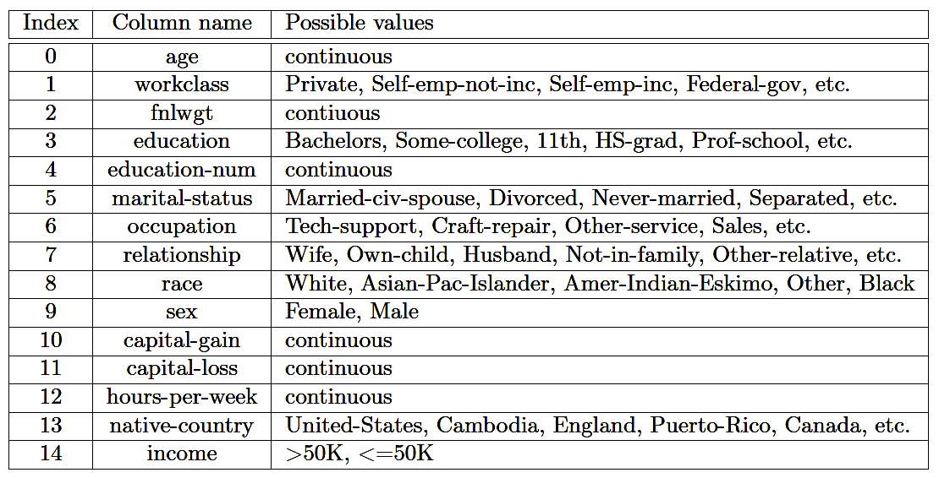

Here are a few Spark API calls that maybe useful for you. You do not need to use all these API calls in your answers. Also if you remember some other API calls which are not included here, feel free to use them in your answers.

def collect(): Array[T]

Return an array that contains all of the elements in this RDD.
def count(): Long

Return the number of elements in the RDD.
def distinct(): RDD[T]

Return a new RDD containing the distinct elements in this RDD.
def filter(f: (T) ⇒ Boolean): RDD[T]

Return a new RDD containing only the elements that satisfy a predicate.
def first(): T

Return the first element in this RDD.
def flatMap[U](f: (T) ⇒ TraversableOnce[U])(implicit arg0: ClassTag[U]): RDD[U]

Return a new RDD by first applying a function to all elements of this RDD, and then flattening the results.
def foreach(f: (T) ⇒ Unit): Unit

Applies a function f to all elements of this RDD.
def groupBy[K](f: (T) ⇒ K)(implicit arg0: ClassTag[K]): RDD[(K, Seq[T])]

Return an RDD of grouped items.
def map[U](f: (T) ⇒ U)(implicit arg0: ClassTag[U]): RDD[U]

Return a new RDD by applying a function to all elements of this RDD.
def mapPartitions[U](f: (Iterator[T]) ⇒ Iterator[U], preservesPartitioning: Boolean = false)(implicit arg0: ClassTag[U]): RDD[U]

Return a new RDD by applying a function to each partition of this RDD.
def reduce(f: (T, T) ⇒ T): T

Reduces the elements of this RDD using the specified commutative and associative binary operator.
def take(num: Int): Array[T]

Take the first num elements of the RDD.
def zip[U](other: RDD[U])(implicit arg0: ClassTag[U]): RDD[(T, U)]

Zips this RDD with another one, returning key-value pairs with the first element in each RDD, second element in each RDD, etc.
def groupByKey(): RDD[(K, Seq[V])]

Group the values for each key in the RDD into a single sequence.
def join[W](other: RDD[(K, W)]): RDD[(K, (V, W))]

Return an RDD containing all pairs of elements with matching keys in this and other.
def lookup(key: K): Seq[V]

Return the list of values in the RDD for key key.
def reduceByKey(func: (V, V) ⇒ V): RDD[(K, V)]

Merge the values for each key using an associative reduce function.

Also given the code below.

scala> val lines = sc.textFile(“/home/cloudera/labs/Lab08/census.txt”)
scala> val split_lines = lines.map(_.split(“, “))

Write spark code to do the following. Your solution can consist of one or more lines of Spark code.

- Output all lines whose sex is “Male” and occupation is “Tech-support”. For matching lines output the entire line.
[6 marks]

- Output the total fnlwgt (fortnightly wage) for each workclass. You can assume that fnlwgt is represented by integers. So the output will look something like:

(Private, 201022)
(Self-emp-not-inc, 312910)
(Federal-gov, 292111)
..etc..

[7 marks]

- For each native-country report the number of people who are “Male”. The output would look something like:

(United-States, 1092)
(Cambodia, 11)
(England, 50)
..etc..

[7 marks]

- Lets break age into 3 categories. Young: 0 - 15; Middle: 16 - 40; and Old: >= 41. Please report the percentage of people in each age category. So the output would look something like (you can use math.round() to remove the decimal place in your answer so it is in whole numbers):

(Young, 25)
(Middle, 40)
(Old, 35)

[10 marks]

Question C
[36 marks]
Suppose you are given the data that contains the first 7 columns of the file used for task 1 of your assignment. Shown below.

Attribute number | Attribute name | Description
1 | Age | Numeric
2 | Job | type of job (categorical: "admin.", "unknown", "unemployed", "management", "housemaid", "entrepreneur", "student",  “blue-collar", "self-employed", "retired", "technician", "services")
3 | Marital | marital status (categorical: "married", "divorced", "single"; note: "divorced" means divorced or widowed)
4 | education | (categorical: "unknown", "secondary", "primary", "tertiary")
5 | Default | has credit in default? (binary: "yes", "no")
6 | balance | average yearly balance, in euros (numeric)
7 | housing | has housing loan? (binary: "yes", "no")

Below you are given problems to solve using MapReduce. First, I will explain what I expect in your answer. You do not need to write actual Java code. Just high-level pseudo code is enough. Please specify what is inside the mapper and reducer in terms of the following three aspects:
- What is the input key and value
- What processing is performed by each map/reduce call
  - Include the emitting of the output key, value pairs.
Feel free to use more than one MapReduce phase if required.

Here is an example of what I mean by pseudo code, although of course it is not the answer to any of the questions ☺

Mapper
- Input Key: byte offset of input line, Input Value: input line
- Inside map function
  - Extract from the input line the balance.
  - Extract from the input line the age.
  - Emit (balance, age)
Reducer
- Input Key: balance, Input Values: set of age values
- Inside reduce function
  - For each age value
Emit (balance, age)

- You are asked to use MapReduce to report the age, job and balance of people who are currently in default (that is the default attribute has value equal to “yes”). You can assume the age and balance attributes are integers. Do not write a combiner or do local aggregation for your answer, since that is the next question. Your output should be something like the following (don’t worry about trivial formatting things like whether the output will have “ “ around the words, etc.):

35 admin. 2132
50 self-employed 1333
etc.

[6 marks]

- Can we use a combiner or local aggregation to reduce the amount of data shuffle for the previous question? If no why not. If yes then write the pseudo code for a combiner or local aggregator for the previous question. Write the combiner or local aggregator in the same format as the pseudo code example given earlier. Please explain how the combiner or local aggregator reduces the amount of data shuffled.

[4 marks]

- You are asked to use MapReduce to find the number of divorced people in each job type. Do not write a combiner or do local aggregation for your answer, since that is the next question. So the output should look something like the following (don’t worry about trivial formatting things like whether the output will have “ “ around the words, etc.).

admin. 100
unknown 29
unemployed 1000
…etc..

[8 marks]

- Can we use a combiner or local aggregation to reduce the amount of data shuffle for the previous question? If no why not. If yes then write the pseudo code for a combiner or local aggregator for the previous question. Write the combiner or local aggregator in the same format as the pseudo code example given earlier. Please explain how the combiner or local aggregator reduces the amount of data shuffled.

[4 marks]

- You are asked to use MapReduce to categorize people into categories based on a combination of Job and Martial status. Therefore someone who is both a housemaid and married would be in the category of (housemaid, married). For each of these combined categories you need to compute the sum of all the balances of people within the category and then report the 3 combined categories with the highest sum. The reported combined category need to be reported in descending order of sum. Please include a combiner or local aggregation in your answer if you feel one can help to reduce the amount of data shuffled. So the output should look something like the following (don’t worry about trivial formatting things like whether the output will have “ “ around the words, etc.).

(admin., married) 2000
(housemaid, divorced) 1900
(unemployed, divorced) 1200

[14 marks]

